PRESS RELEASE TEMPLATE
Use the following press release as template for dissemination to local media.
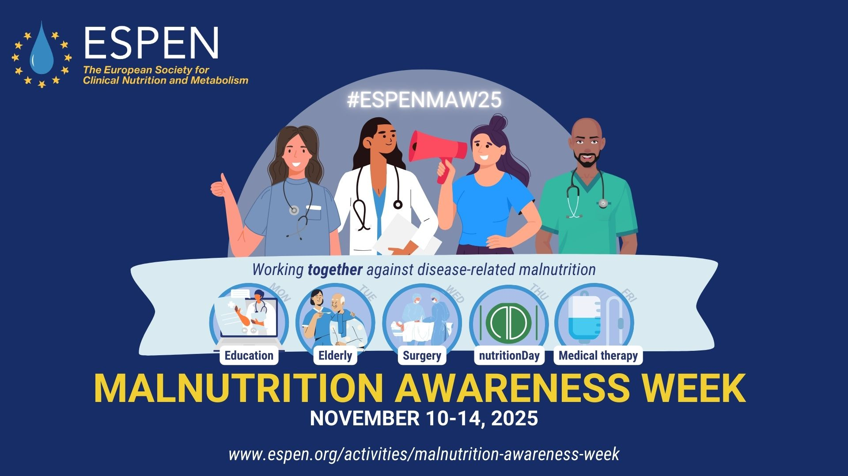
Complete the text in red with relevant information of your organization, institution, PEN Society.

Issued by: [The European Society for Clinical Nutrition and Metabolism (ESPEN)] – or – [XcountryX Society for Clinical Nutrition and Metabolism (XxxSPEN)]
ESPEN Malnutrition Awareness Week 2025, November 10 – 14th

Worldwide awareness drive aims to reduce malnutrition among patients.

Campaign highlights that ‘Malnutrition worsens Disease’

Monday November 10th-14th: This week, nutrition and medical expert organisations from around the world are uniting in an international effort to make everyone more aware of the impact of malnutrition on disease treatment and recovery, including patients, healthcare professionals from all disciplines and policy makers.

Launching the Malnutrition Awareness Week campaign, ESPEN and (ENTER NAME OF SOCIETY) are committed to achieving the best possible nutritional care for every patient in every setting. To reach this goal there is also a strong need to increase awareness on the huge impact of malnutrition, and the availability of safe and effective treatment through nutritional care. The campaign aims at getting the message out that ‘malnutrition worsens disease outcomes’, and that nutritional care needs to be given far greater priority as part of a patient’s treatment, in every care setting.

During this year’s Malnutrition Awareness Week campaign, ESPEN will collaborate with its 69 block-member national Clinical Nutrition Societies worldwide and other partners, who will also be able to use and promote ESPEN malnutrition week locally, organising educational and promotional events aimed at involving as many different disciplines and stakeholders as possible.

As malnutrition worsens outcomes in all diseases, this year, ESPEN will partner with the The European Geriatric Medicine Society (EuGMS) to highlight the role of nutrition in elderly patients and with the ERAS Society to learn more about the role of nutrition in surgical patients, running joint educational webinars and events which can be freely accessed by all participating countries. These initiatives are part of ongoing strategies to promote basic and advanced education on the role of malnutrition and its negative impact on disease outcomes.

As in previous years, ESPEN will be also working closely with European Nutrition for Health Alliance (ENHA) to promote malnutrition week activities.

Expressing concern about the low priority given to identifying and treating malnutrition, despite serious consequences for patients and huge costs for healthcare systems “awareness remains low that poorer outcomes occur when a patient’s nutritional needs are not met. Malnutrition is a disease that may complicate all other diseases, and it affects all organs in the body. For instance, loss of skeletal muscle is very common, leading to weakness, frailty, loss of autonomy and poor quality of life. This is especially problematic in older patients. But muscle loss also leads to infections, risk of type 2 diabetes and may become a fatal complication in itself. ”

Disease-related malnutrition (DRM) is estimated to affect at least 30 million people in Europe alone¹, and nutritionDay survey data from across Europe shows that one in four patients admitted to hospitals are malnourished or at risk of malnutrition², increasing their risk of complications and compromising their recovery. In addition, treatment becomes on average three times more expensive³, due to more hospitalisations, longer length of stay and poorer results, making the problem extremely costly for healthcare systems.

One of the problems contributing to the low awareness of the importance of DRM is poor training of healthcare professionals. 30% of European medical curricula do not include any education on clinical nutrition⁴. (Insert local situation here) ESPEN is therefore working to improve this through its Nutrition education in medical schools (NEMS) initiative.

Many patients also do not realize how important nutritional care is to their recovery. Highlighting this fact, Prof X (e.g. local organisation PEN leader or dietitian) said that “Nutritional care provides evidence-based effective and safe treatment for disease related-malnutrition, and it has the potential to improve outcomes, quality of life and survival. As food is a fundamental right for every human being, nutritional care is a human right for every patient who is unable to feed him- or herself effectively. Neglecting nutritional care in healthcare systems is therefore unacceptable, both ethically and clinically, but awareness of its importance is unfortunately low in healthcare professionals and policymakers.”

ESPEN experts urged far greater focus on nutrition in healthcare, saying “It is time to act. As doctors and healthcare professionals, we really cannot claim to be providing high quality medical care if we are ignoring the patient’s nutritional status. ESPEN Malnutrition Awareness Week aims at promoting new strategies and actions to improve healthcare for all citizens and save patient lives”.

For information on Malnutrition Awareness Week and how you can support the campaign, see: https://www.espen.org/education/malnutrition-awareness-week

ESPEN Malnutrition Awareness Week 2025 Activities
- Webinars in collaboration with Societies in surgery and elderly fields
- Worldwide data collection on nutritional care provided in hospital, nursing homes and in Primary care settings (nutritionDay)
- Dissemination of ESPEN educational material for comprehensive nutrition teaching in medical schools (NEMS)
- Social media Campaign to raise awareness for disease related malnutrition and the importance on nutritional care
- Activities organized by the national Clinical Nutrition Societies worldwide (videos)

Further Information
European Society for Clinical Nutrition and Metabolism (ESPEN): https://www.espen.org

[XcountryX] Society for Clinical Nutrition and Metabolism [(XxSPEN): https://www.XXXXX.

- Guest JF, Panca M, Baeyens JP, de Man F, Ljungqvist O, Pichard C, Wait S, Wilson L. Health economic impact of managing patients following a community-based diagnosis of malnutrition in the UK. Clin Nutr. 2011 Aug;30(4):422-9. doi: 10.1016/j.clnu.2011.02.002. Epub 2011 Mar 13. PMID: 21406315.
- Tarantino S, Hiesmayr M et al.; nDay working group: nutritionDay Worldwide Annual Report 2019. Clin Nutr ESPEN. 2022 Jun;49:560-667. doi: 10.1016/j.clnesp.2022.01.001.
- Stratton RJ et al. Managing malnutrition to improve lives and save money. BAPEN, 2018. Available from: https://www.bapen.org.uk/resources-and-education/ publications-and-reports/malnutrition
- Cuerda C, Schneider S, Van Gossum A. Clinical Nutrition education in medical schools: Results of an ESPEN survey. Clin Nutr 2017; 36: 915-6.
- World Health Organization. Regional Office for Europe. (‎2023)‎.
Disease-related malnutrition: a time for action. World Health Organization. Regional Office for Europe. https://iris.who.int/handle/10665/375033. License: CC BY-NC-SA 3.0 IGO

